Diagnosis of Covid-19 from CT scan and X-ray dataset

# Abstract

COVID-19 is a serious global concern, and artificial intelligence (AI) can help reduce losses by monitoring and finding infected people early on. The aim of this paper is to explain about my experimentation done to diagnose COVID-19 through ml techniques. In this paper I've used three datasets in my experimentation: sars cov, covidxct, omniglot. Initially i’ve used resnet, squeezenet, traditional cnn to classify covid -19 patients in sars cov dataset. After that, as covidxct has 3 class normal, pneumonia, covid i’ve modified my model to fit this dataset. Next in this medical field availability of datasets is very hard so we need to have a model that requires less amount of data i.e using few shot learning approaches. Next I've used a matching networks model to classify covid-19 patients. After these experimentations I've understood that resnet 34 without freezing the layers using cross entropy loss function gives better results than other models.

**Keywords**:

Resnet,cnn,deep learning,ct scan,x-ray,squeezenet, few shot learning, COVID, matching networks

# Introduction

The World Health Organization (WHO) declared an outbreak of a novel viral illness to be a worldwide public health concern on January 30, 2020, and on February 11, 2020, WHO designated the disease caused by the new coronavirus COVID-19. The first COVID-19 cases were discovered in Wuhan, China. These individuals were linked to a local wild animal market, suggesting that the virus might be transmitted from animals to humans.The novel coronavirus caused a catastrophic outbreak in China, which quickly spread to neighbouring nations. Many political, economic, and sports events were disrupted by the virus, which impacted the lives of many individuals throughout the world.The potential of the novel coronavirus to spread quickly and widely is its most essential trait. The virus is mostly transferred directly from infected persons to others; however, it may also be spread indirectly through surfaces and air in the environment when infected people come into touch with it. As a result, appropriately diagnosing the symptoms of those who have the disease and quarantining them plays an important role in disease prevention. A new coronavirus infects the lungs, causing viral pneumonia and severe acute respiratory syndrome.The novel coronavirus generates a wide range of symptoms in those who are infected. Fever, dry cough, and exhaustion are the most frequent signs of a new coronavirus infection. The signs and symptoms of this illness differ from person to person. Other symptoms such as loss of smell and taste, headache, and sore throat may occur in some people, but severe symptoms such as shortness of breath, chest discomfort, and loss of capacity to move or speak suggest that COVID-19 is progressing.

The reverse transcriptase-polymerase chain reaction (RT-PCR), isothermal nucleic amplification test, antibody test, serology testing, and medical imaging are all used to make a conclusive diagnosis of COVID-19 .The major approach for diagnosing COVID-19 and many other viral illnesses is RT-PCR. However, the approach is limited for some tests since developing new assays requires more skill and experimentation . Furthermore, the scarcity of diagnostic kits in the majority of polluted places throughout the world is forcing researchers to devise new and simpler methods of diagnosing the disease.The researchers use CT scans and X-rays to identify COVID-19 because medical imaging instruments are readily available in most treatment locations.Infections with novel coronavirus are discovered in the lungs of most COVID-19 patients, which can aid in the diagnosis of the condition. The novel coronavirus induced pneumonia in individuals with COVID-19, according to CT scans. After radiologists approved the use of CT scans and X-rays to identify COVID-19, numerous strategies to exploit these images have been developed.Most patients with COVID-19 symptoms have X-rays and CT scans of their lungs at least four days later, which indicate infections that prove the existence of a novel coronavirus in their body. Medical imaging is not advised for final diagnosis, however due to the limitations of other modalities, it can be utilised for early COVID-19 diagnosis.On CT scans, several patients with early-onset COVID-19 symptoms had fresh coronavirus infections. Their RT-PCR test results came back negative at the same time, so both tests were redone a few days later, and RT-PCR corroborated the CT scan's diagnostic results. Although medical imaging is not indicated for a conclusive COVID-19 diagnosis, it can be used as a main diagnostic approach to confine the Suspicious individual and prevent the virus from spreading to others in the early stages of the disease. The capacity to visualise viral infections using machine vision is one of the benefits of employing medical imaging.Machine vision and deep learning have a wide range of applications in medical, agriculture, economics, and other sectors, eliminating human mistakes and enabling automation. One of the most effective techniques to identify tumours and infections caused by various diseases is to combine machine vision and deep learning. This technology has been used for a variety of medical imaging, including brain and skin lesions, and state-of-the-art bone suppression in x-ray images.

In this paper I've explained about the journey of my experimentations done for detecting of covid-19 using machine learning and deep learning techniques. In the beginning of the PE I learnt about what CT scan and how they are formed and what is the difference between x-ray and CT scan. Next, we are given a paper on DETECTING COVID-19 FROM A NEW AND LARGE LUNG CT SCAN DATASET. From this I've learnt how a basic deep learning pipeline should be implemented and learnt very important models Basic CNN, FPN, Resnet and I have understood the code in keras and converted it into pytorch. My whole project has been implemented in pytorch. Next, I was given a 3D image classification code. I ran the code and converted the code into pytorch and explained about the intermediate data modifications happening for the images. In this I've understood the difference between 2d cnn and 3d cnn and how 2d and 3d data analysis differ and I’ve taken this opportunity to dive deep to understand CNN thoroughly. Next, we got time to discuss our project tasks. There were two tasks: abnormal slice detection-volumetric data detection, and segmentation. I’ve chosen an abnormal slice detection-volumetric data detection task to work on. Initially i was given a 2d analysis sars cov, covidxct dataset. I’ve analyzed and done basic preprocessing for the sars cov dataset and prepared data loaders for the dataset. Next, I've started working on deep learning models. As resnet is the most popular architecture and produces better results compared to traditional cnn in most of the cases and has flexibility to increase number of layers when complexity of dataset is high without hurting the performance of the model. And the speciality of squeezenet is it requires low storage space. This kind of model is very useful especially in medical fields. Unique thing about resnet is skip connections and for squeezenet is squeeze and expand unit(fire module) in the architecture which was inspired from inception. From this I've learnt residual block, vanishing gradient problem, why resnet works better than traditional cnn, squeezenet’s design patterns, fire module, architecture. Finally i’ve implemented resnet-18, squeezenet for the sars cov dataset. Next, I've experimented with very resnet’s(18,34,50,152),squeezenet. For every learning algorithm I've taken results for 4 variants(with freezing of layer+cross entropy loss function,with freezing of layer+focal loss loss function,without freezing of layer+cross entropy loss function,without freezing of layer+focal loss loss function). Resnet-34+without freezing+cross entropy loss function variant outperformed all other variants. Now I've applied the same variant on the covidxct dataset. On top of it I've tried out the same variant with Adam optimizer, cosine annealing, lt schedulers and l2 regularization. I’ve learnt about the role optimizers, it’s intuition and understood the adam optimizer and it’s working. With that i’ve understood about adamw,amstrad. Next, I've learnt about what schedulers do and discovered different schedulers and understood cosine annealing. Understood the concept of overfitting and how l2 regularization is used to overcome overfitting. Next, I've implemented the Resnet-34+without freezing+cross entropy loss function variant for covidxct dataset using the same weights which I got after training for sars cov dataset instead of random initialization. This experiment was successful and I found very good insights from this experimentation. Next, apart from traditional training of deep learning algo’s now I've experimented with few shot learning. The reason why we have chosen few shot learning is that in medical field the available datasets are very rare so we have crisis of datasets so for the generalizability of the model we need to have an learning algorithm which needs lesser amount of data similar to how a chi;ld could identify the difference of two animals in the first go. Initially I've started looking for different papers and finally started with the Siamese network . It was a basic network that gave average results so upgraded to matching networks. I’ve learnt about matching networks and famous datasets in few shot learning areas. I’ve trained the matching networks for the omniglot dataset and used it for the sars cov dataset and obtained pretty good results.

In this paper, I've explained about the datasets used in my experimentations. I’ve shown the objectives, method, results and inferences in each tasks section. Atlast i gave links for codes and my presentations.

# Materials(Datasets):

### **sarscov:**

SARS-CoV-2 CT scan dataset contains 1252 CT scans that are positive for SARS-CoV-2 infection (COVID-19) and 1230 CT scans for patients non-infected by SARS-CoV-2, 2482 CT scans in total. These data have been collected from real patients in hospitals from Sao Paulo, Brazil. The aim of this dataset is to encourage the research and development of artificial intelligent methods which are able to identify if a person is infected by SARS-CoV-2 through the analysis of his/her CT scans.

### **covidxct:**

COVIDx CT-2 is divided into two variants: "A" and "B". The "A" variant consists of cases with confirmed diagnoses (i.e., RT-PCR, radiologist-confirmed, etc.). The "B" variant contains all of the "A" variant and adds some cases which are assumed to be correctly diagnosed but are weakly verified. Notably, the additional images included in this variant are only added to the training set, and as such the validation and testing sets are identical to those of the "A" variant.

The COVIDx CT-2 dataset is released as a directory of images (2A_images) and associated label files ({train,val,test}_COVIDx_CT-2A.txt) indicating classes and bounding boxes for the body region.

Each line in the label files has the following format:

filename class xmin ymin xmax ymax

Classes are zero-indexed with Normal=0, Pneumonia=1, and COVID-19=2, and bounding boxes are given in original image coordinates.

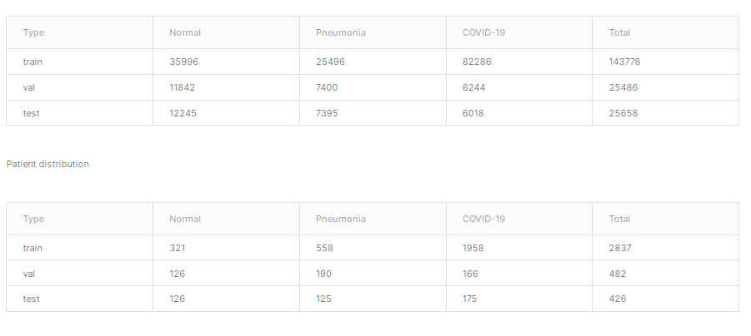

### **omniglot**

It is a dataset containing 1623 characters from 50 different alphabets, each one hand-drawn by a group of 20 different people. This dataset was created for the study of how humans and machines adapt to one-shot learning, i.e. learning a task from just one example. The omniglot dataset has been prepared in such a way that each character in the above image has been written by 20 different people. 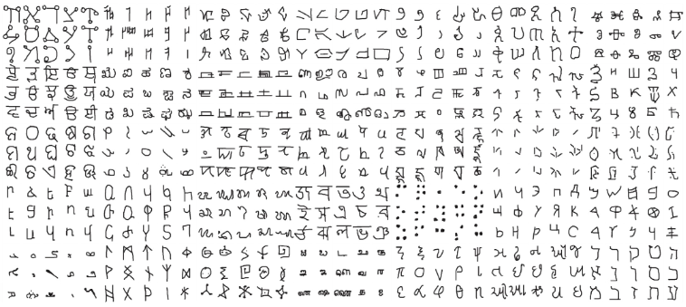

# OBJECTIVE:

# Task1:

## Objective:

Learn and understood following

How CT scans are formed.

How x-rays are formed

What is the difference between Ct-scan and x-ray image.

## Results:

**How CT scans are formed.**

**How x-rays are formed**

**What is the difference between Ct-scan and x-ray image.**

* + CT-Scan machine consist of X-ray and it's detector.
  + CT-Scan machine looks like doughnut in shape.
  + In which this X-ray and it's detector are placed diametrically opposite.
  + Now a person will be sent into this machine.
  + this X-ray and detector will be rotating.
  + this X-ray emitter send x-rays from different angles and it's detector captures it.
  + and a single image looks like a single line with shades of gray.
  + shades of gary is formed due to sums of densities in the projection line.
  + all the images from a single rotation are taken and processed and forms a axial slice of the body.

# Task2:

## Objective:

Given a A FULLY AUTOMATED DEEP LEARNING-BASED NETWORK FOR DETECTING COVID-19 FROM A NEW AND LARGE LUNG CT SCAN DATASET paper understand the paper and run the code

What is 1*1 convolution in FPN?

How three features are extracted from the top layer of FPN?

Run the code

Calculate the dimension differences occurring while using FPN.

## Results:

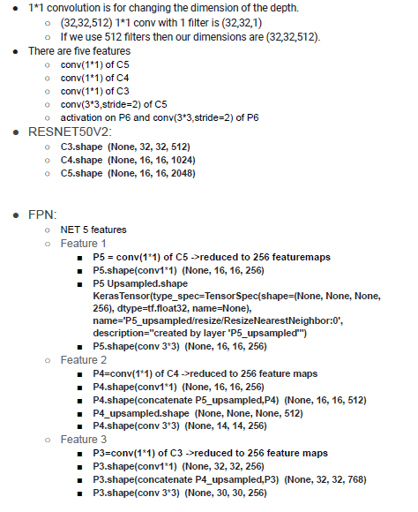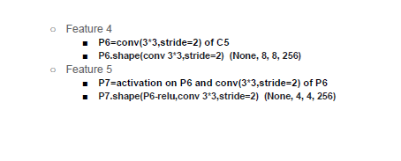

# Task3:

## Objective:

Given a 3d image classification code from CT scans convert it into pytorch

## Method:

I’ve understood the code in keras and i’ve searched for similar code in pytorch and implemented the same in pytorch.

## Results:

I’ve given the link for the code folder.

# Task4:

## Objective:

Understand the sars cov dataset.

Do some preprocessing for the sars cov dataset.

Construct data loaders for sars cov dataset.

Learn resnet and squeezenet

Figure out what is special about resnet and benefits of using resnet.

Figure out the intuition behind vanishing/exploding gradients problem.

Use pretrained resnet -18 available in torchvision library for sars cov and show the results.

Use pretrained squeezenet available in torchvision library for sars cov and show the results.

Experiment with resnet-18,34,50,152

Experiment with different loss functions : cross entropy, focal loss.

Experiment with freezing of layers and not freezing the layers of learning algorithms during transfer learning.

Do cross validation

Check whether the training is over fitting or not.

Perform patchwise training

## Method:

Initially i’ve imported all the required libraries. As the sars cov dataset is given in the form of class classification so i’ve splitted the dataset into train,val,test datasets. I’ve resized all the images to (224,224) shape to input the image into the model. Constructed the datasets and dataloaders. Implemenetd a basic ImageClassificationBase class which can be used for any classification tasks. Function fit to fit the model to the dataset it trains and validates the model. Implemented a model_number_freezemode function. Where model_number: resnet_34,50,152,squeezenet and freezemode:WF,WOF. And each code file it shows the results with cross entropy and focal loss. Next i’ve implemented the same for covidxct dataset.

## Results:

In pursuit of finding which variant performs well we have implemented the codes using torchvision library in kaggle. Here are the results.

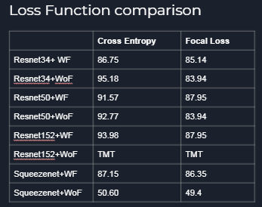

From this table we can understand that cross Entropy is the best loss function.

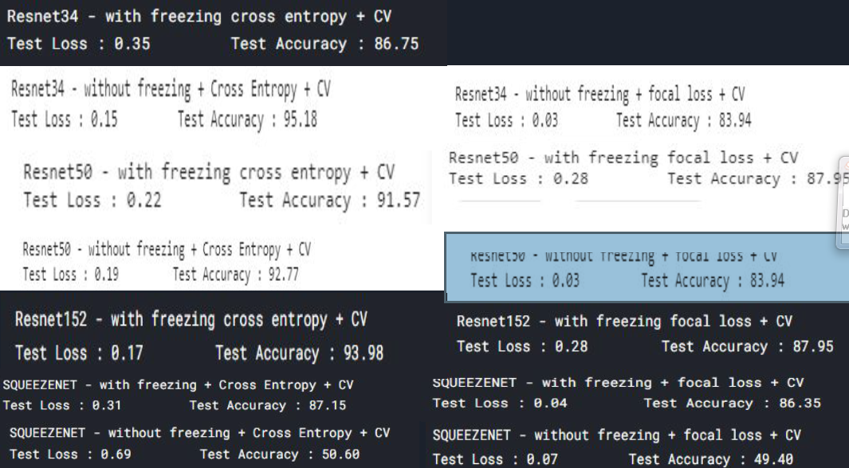

From this table we can understand that Resnet34 + wof is performing better than other models.

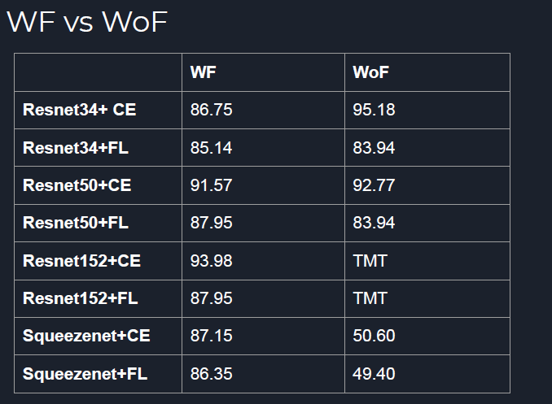

Resnet34 is the best model.

Resnet50 also performs better.

Number of layers in resnet increases then it’s performance is hurting.

So Resnet34 is the chosen model.

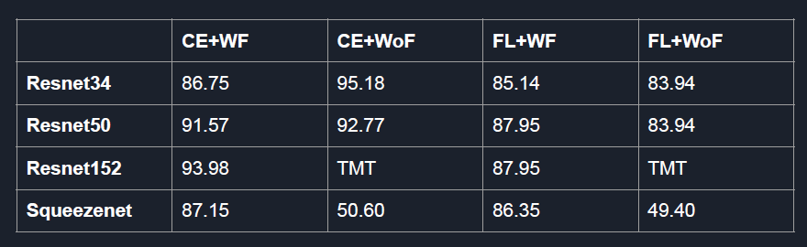

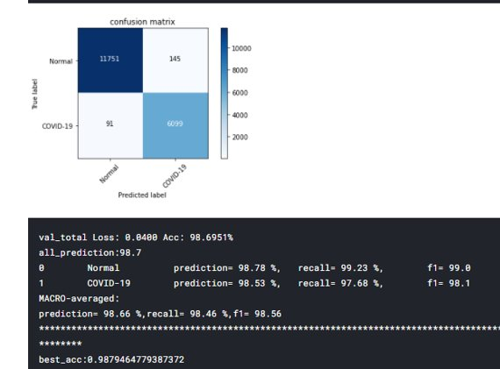

This confusion matrix is for covidxct dataset.

Trained for 25 epochs​

Took almost 8-9 hrs​

Best Acc : 98.8%​

Test Acc : 98.6%

## Inferences and Conclusions:

* Top Model : Resnet34
* Better combinations:
  + Resnet34+CE+WoF
  + Resnet50+CE+WoF
  + Resnet152+CE+WF
* Best loss function : Cross Entropy
* **Best variant** : Without freezing

# Task5:

## Objective:

Use few shot learning approach for the abnormal slice detection.

Understand the difference between supervised and one shot learning

Understand the concept of n-way k-shot learning

Matching networks architecture.

Implement the matching networks on sars cov.

## Method:

I’ve used pytorch library to implement matching networks and used it for the covidxct. Initially I trained on an omniglot dataset. Next, i’ve defined a label set with 3 classes 5 images per each class(3 way 5 shot learning).Combine both embedding and classification to form an end to end differentiable nearest neighbour classifier.​

Steps:​

* Embed a high dimensional sample into a low dimensional space(FCE)​
* Perform a generalised form of nearest neighbours classification(Similarity function)​

FCE:

* G – embedding of support set, Encode each support sample in context of it's neighbours within support set(S).​
* F - Embedding of targets, Encode targets in context of it's support

ATTENTION KERNEL:

* Softmax over cosine distance between f(x,S) and g(X_i) : distance between target embedding and support sample embedding.

## Results:

Initially i’ve ensured that there is no data leakage. And to avoid class imbalance i’ve used a technique to remove the class imbalance in the dataset.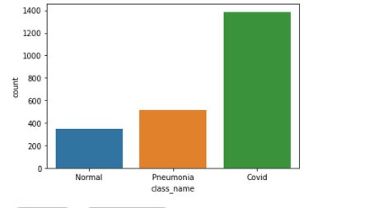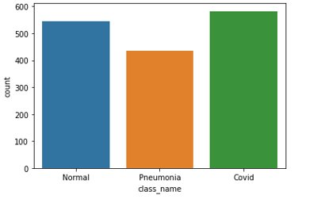

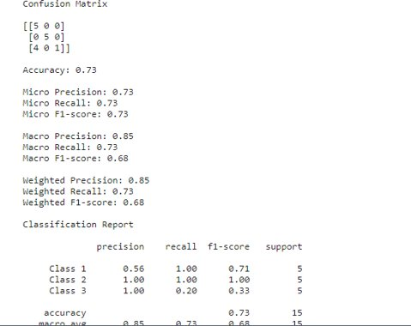

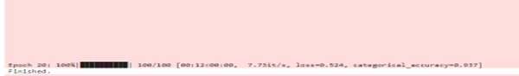

I’ve trained the model for 20 epochs and it’s giving 93% accuracy.

# Conclusion:

After doing all these experiments the final point I've understood is that resnet34 without freezing the layer but using the trained weights of sars cov as the initial weights is performing better than other models. For further improvement of image based diagnosis techniques we can exploit the power of few shot learning and learn with a lesser amount of data. After completion of this project i’ve learnt pytorch, deep learning algorithms and few shot learning techniques, colab, kaggle. Every week I need to present my results and the concepts I've learnt so with that i’ve improved my presentation skills as well. I would like to thank gopika ma’am who guided me and gave suggestions whenever I needed and has given scope and time to pick up quickly. I would like to thank neelam ma’am who has given this wonderful opportunity to hone our skills.

# Links and codes and slides:

### Presentations:

* [Resnet_squeezenet](https://docs.google.com/presentation/d/12baRHAs7BlBhhM2ndfd-XX24lWyKByInIiSTxv8VTng/edit?usp=sharing)
* [CNN](https://docs.google.com/presentation/d/196GWA5Gny8MIYvEgA-baE5kqwQXDoSO0KAtZEBDFhMI/edit?usp=sharing)
* [Resnet34](https://docs.google.com/presentation/d/1V3WBdv_pdvt5Ailg86jgFBA4LXbU9_MbnRnD2xXyAHM/edit?usp=sharing)
* [COVIDXCT](https://docs.google.com/presentation/d/1p54uBH49b_M4Ac8-0z_tKfdlq5k7YRfSpIdl3sHefIo/edit?usp=sharing)
* [Task4_results](https://docs.google.com/presentation/d/1IWDdL768IfVqYKbOLlfMbMj53UEcXPcjcqk2BgwocVc/edit?usp=sharing)
* [resnet34_wof_on_COVIDXCT](https://iiitbac-my.sharepoint.com/:p:/g/personal/anjan_vikas_iiitb_ac_in/EWoTq41SZdVHkgjR-KABBg4BwvKSqkJgP3XyZCSEOadoOw?e=CZIOio)
* [Few shot learning paper](https://iiitbac-my.sharepoint.com/:p:/g/personal/anjan_vikas_iiitb_ac_in/EaVLiiNDmixNi3GmeiT_M4gB57dYole_G6CcLtY6M5YlFw?e=2GZ1IK)
* [Matching networks and it’s results](https://iiitbac-my.sharepoint.com/:p:/g/personal/anjan_vikas_iiitb_ac_in/ER28W9S_SrhJuFWBwcrV5mEBte3q25Eh9CXd9qHlRWBGAA?e=bLvR4g)
* [Tasklogs](https://docs.google.com/presentation/d/1ZTZhTH7_FaFmYx3FZWwIgX9CqPmQkMyWxpYY8WRxgcI/edit?usp=sharing)

### Codes and images:

* [Codes and images](https://github.com/anjanvikas/PE)
* [task4_plots](https://drive.google.com/drive/folders/1_lzAcNYbMrt8VZdbjPqdIZaDXs8zClHU?usp=sharing)

# References:

* <https://towardsdatascience.com/an-overview-of-resnet-and-its-variants-5281e2f56035>
* <https://towardsdatascience.com/illustrated-10-cnn-architectures-95d78ace614d>
* <https://www.coursera.org/in>
* <https://www.analyticsvidhya.com/blog/2021/05/an-introduction-to-few-shot-learning/#:~:text=Few%2Dshot%20learning%20is%20the,generalize%20to%20the%20test%20set>.
* <https://neptune.ai/blog/understanding-few-shot-learning-in-computer-vision>
* <https://arxiv.org/abs/1602.07360>
* <https://pytorch.org/tutorials/>